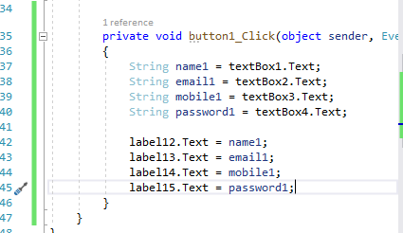

String name1 = textBox1.Text;

String email1 = textBox2.Text;

String mobile1 = textBox3.Text;

String password1 = textBox4.Text;

label12.Text = name1;

label13.Text = email1;

label14.Text = mobile1;

label15.Text = password1;

